Hearthstone Database Demonstration Test Plan

Santosh Lakshman, Barr Avrahamov, Gokul Nair, Noah Gutierrez

1. Open exe

2. Demonstrate file path choosing

a. Use default path

3. Demonstrate Sorted Output

a. Show output

4. Demonstrate Add function

a. Show input validation

i. Type invalid values first and then type properly formatted values

5. Demonstrate Remove function

a. Remove an element that was in the file already

b. Remove the same element again

i. Show that you can’t remove an item not in the list

6. Demonstrate hash table Efficiency

a. Show output

7. Demonstrate Indented BST Feature

a. Show output

8. Demonstrate hash table sequence

a. Show output

b. Show that the elements added and removed are consistent

9. Demonstrate Sorted output

a. Show output

b. Show that elements are consistent with hash table output

10. Demonstrate Card pack opening

a. Show output

b. Describe the rarities of each card

c. Run twice to show random output

11. Exit Program and open again using the same file

a. Demonstrate that all previous changes were saved to the file

i. Print sorted output

12. Open CSV file in Excel to show easy editing

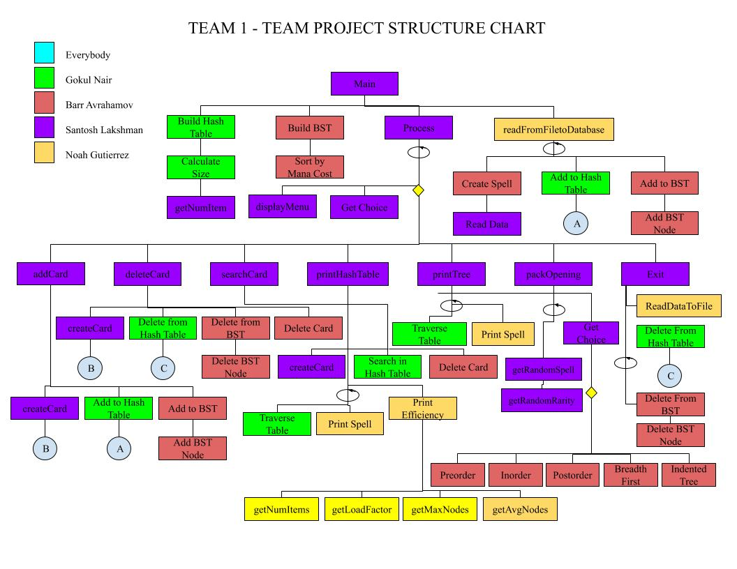Structure Chart

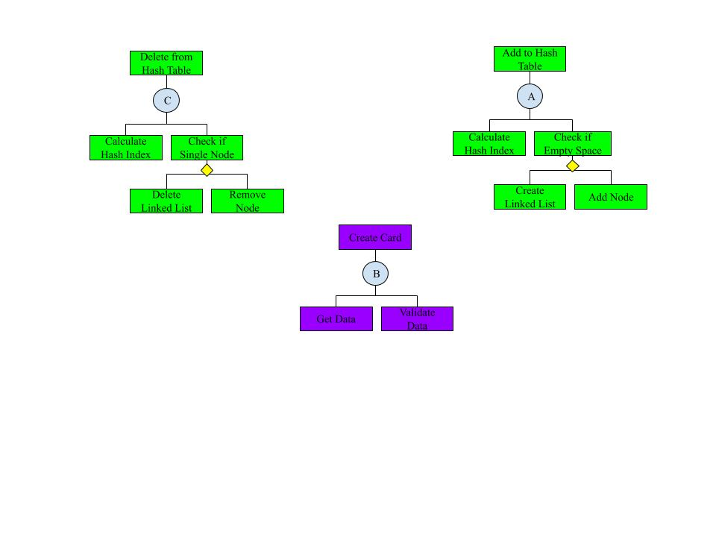

UML

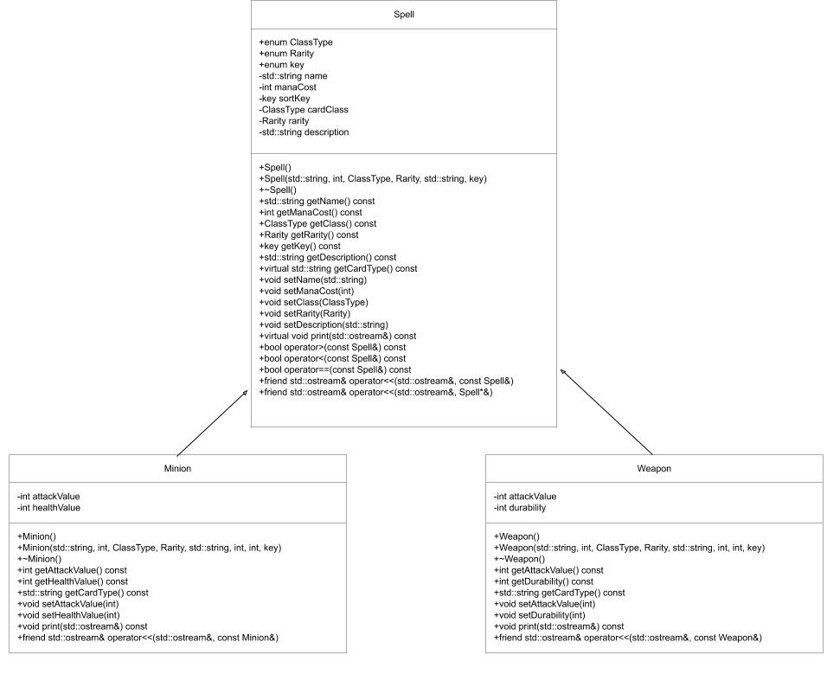

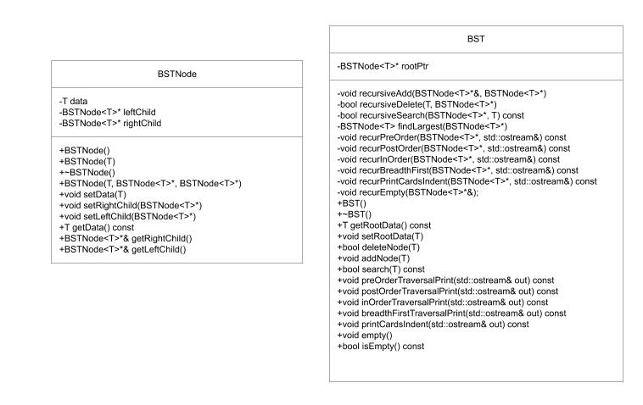

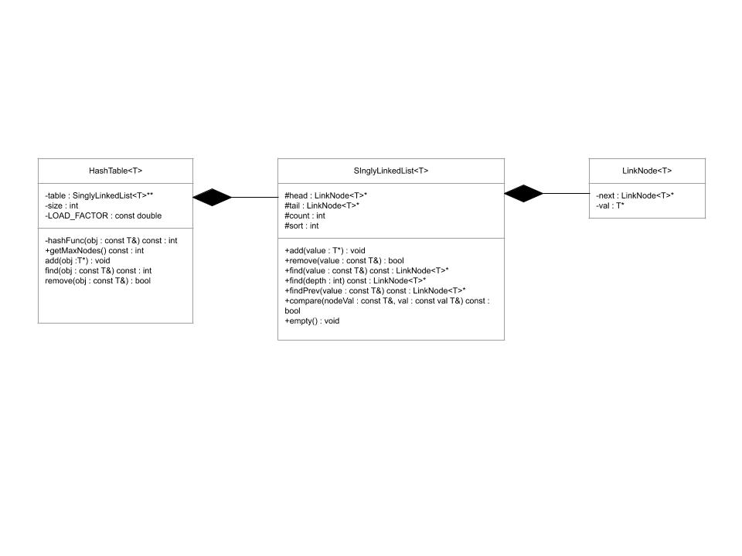

Data Structure Diagram